**Getting started**

Welcome to Genomica de Poblaciones y RAD-Seq!

The format of the workshop will typically consist of lectures about population genetics theory in the mornings and hands-on computational activities during the afternoons. During our first week, we will focus on using the bioinformatics pipeline in STACKS to process ddRAD-seq data. During the second week, we will analyze ddRAD-seq data to calculate genetic parameters about real populations.

Note that the course will be taught in English, and all instructions are provided in English. Some programs (e.g., R) have an option to set the language to Spanish. Unless you are proficient in these programs, I recommend setting the language to English so that you can copy and paste the command lines that I provide.

We will be using the following five programs. **It is strongly recommended that you download and install all programs prior to the start of the course.** I also suggest creating a folder named “**PopGen**” where you will keep all the documents for this course.

**Part I. Bioinformatics Pipeline**

Install Windows Subsystem for Linux (WSL)

* + - For **help**, visit <https://learn.microsoft.com/en-us/windows/wsl/install>

1. Open Windows PowerShell or other command prompt by clicking start, searching, right-clicking on the icon, and selecting "Run as administrator"

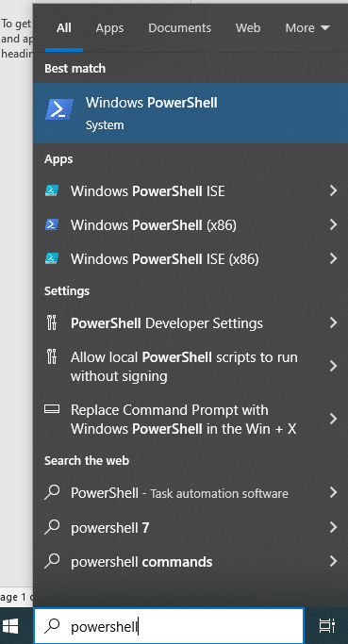

1. On the command line, type **wsl --install**
   * You should see the progress of installation as below



* Once complete, Ubuntu will be installed automatically



1. Restart your computer
2. Open Ubuntu from the Start Menu
3. If you were not already prompted in WSL, you will be asked to create a username and password

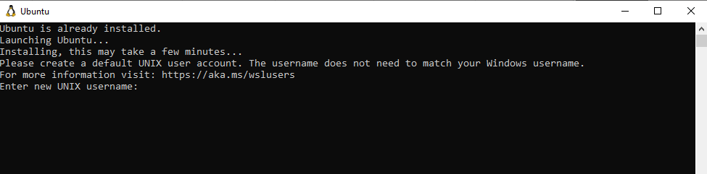

Create a Folder for Course

1. Create a folder named **PopGen**
2. Open Ubuntu from the Start Menu
3. Navigate to your **PopGen**
   * WSL stores your Windows drives in the /mnt folder, with the name of the drive as a subfolder. For example, your C:\ drive will be present at /mnt/c/ for you to use.
   * The easiest way to navigate to the folder is to open your folder in Windows, highlight the address, right-click, and copy; paste the address onto the command line after *cd /mnt/*

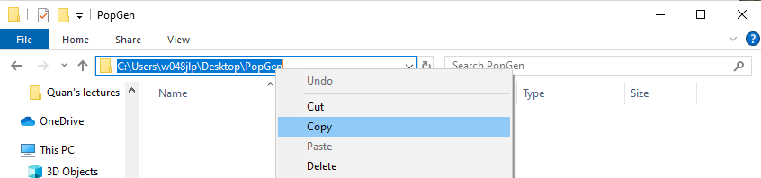

* + Then change “C:” to “c” and replace “\” with “/”
  + *cd /mnt/c/Users/w048jlp/Desktop/PopGen*

Build Stacks

1. Go to <https://catchenlab.life.illinois.edu/stacks/> and Download Stacks



1. Move the downloaded file **stacks-2.66.tar.gz** to your PopGen folder
2. Type the following commands at the prompt
   * *tar xfvz stacks-2.66.tar.gz*

*You should see a long list of installations scrolling past:

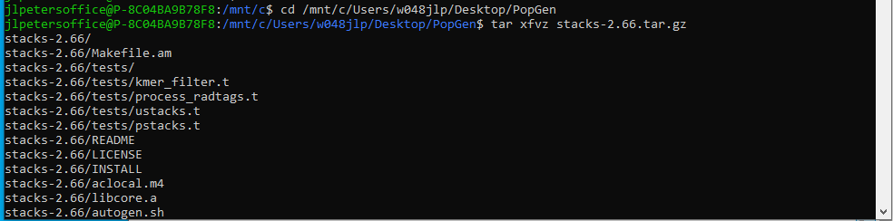

* + *cd stacks-2.66*
  + *./configure*
  + *make*

**Troubleshooting:**

If you get the following error: 

Then try the following:

* + *sudo apt install g++*
  + *sudo apt install zlib1g-dev*
  + *./configure*
  + *make*

If you get an error that “**aclocal-1.13 command not found**”, then try running:

* + *autoreconf -f -i*
  + *make*

If you get “**Warning: Clock skew detected**”, try running:

* + *touch \**
  + *make*

1. To install stacks, type: *sudo apt install stacks*

**Part II. Other Programs**

1. **R for Windows**
   1. Note that distributions are available for Windows, Mac, and Linux, but I have only used the Windows version.
   2. Go to https://www.r-project.org/
   3. Click “download R” and choose the mirror for Colombia (Icesi University)
   4. Choose “Download R for Windows” (or “…(Mac) OS X” or “Linux”, depending on your operating system”), and then “install R for the first time”.
   5. Choose “Download R 4.4.0 for Windows” and Save File.
   6. Execute the file “R-4.4.0-win.exe”.
   7. Go through the steps, leaving the default options checked, to install the program. Once it finishes, click “Finish”. (Additional help can be found by clicking the link “[Installation and other instructions](https://cran.case.edu/bin/windows/base/README.R-3.6.0)” located below the “Download R 4.4.0 for Windows” link on the website.
   8. Execute R
   9. Type **install.packages("adegenet")** on the command line
      1. If you get the error, “lib = "C:/Program Files/R/R-4.4.0/library"' is not writable”, then you will need to restart R with administrator privileges. To do so, close R and right-click on the R icon and choose “Run as administrator”.
   10. Once this package is installed, you will be ready for data analysis.
2. **BayeScan** 
   1. Go to <http://cmpg.unibe.ch/software/BayeScan/>
   2. Click on Download from the blue bar at the top of the screen
   3. Scroll down and click on the icon to download:

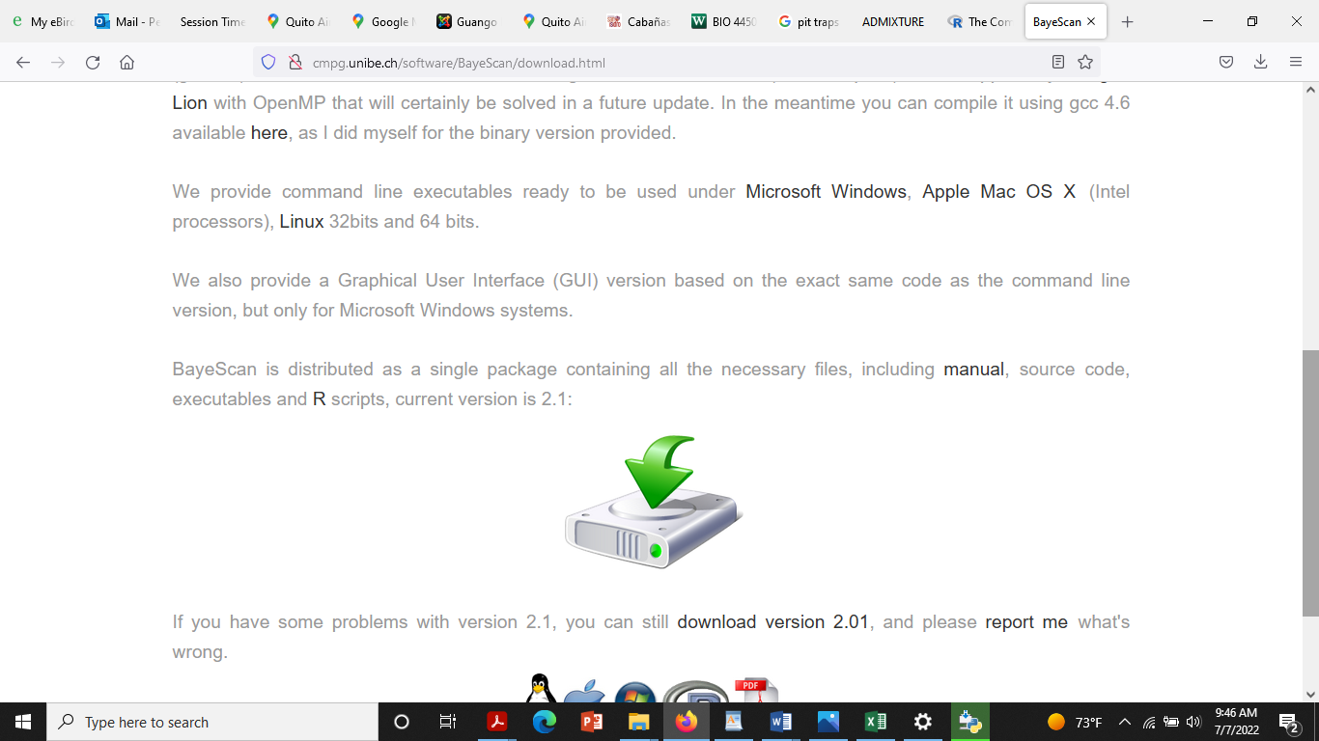

* 1. Move the downloaded file “BayeScan2.1.zip” to your PopGen folder.
  2. Unzip the folder: right click on the folder and select “Extract all…”
  3. You should now be ready to use BayeScan

1. **STRUCTURE** <https://web.stanford.edu/group/pritchardlab/structure_software/release_versions/v2.3.4/html/structure.html>
   1. Download package with graphical front end: For Windows XP/Vista/Windows 7 : [Windows] (Mac OS X and Linux are also available, but I have not used those)
   2. Move the downloaded file, Structure.msi, to your PopGen folder
   3. Double-click on Structure.msi to begin the installation process
   4. Follow the instructions to complete installation
2. **starBEAST2**
   1. Install BEAST2
      1. Go to <http://www.beast2.org/>
      2. Scroll down to “Download for Windows (90MB)”
      3. This will download a zipped folder: BEAST.v2.7.6.Windows.zip
      4. Move this folder to your PopGen folder
      5. Unzip the folder: right click on the folder and select “Extract all…”
   2. Install starBEAST2
      1. Open the folder “BEAST.v2.6.7.Windows”
      2. Open the folder “BEAST”
      3. Execute the file “BEAUti.exe” by double-clicking on the icon
      4. If you get the following warning, click on “More info” and click “Run anyway”:

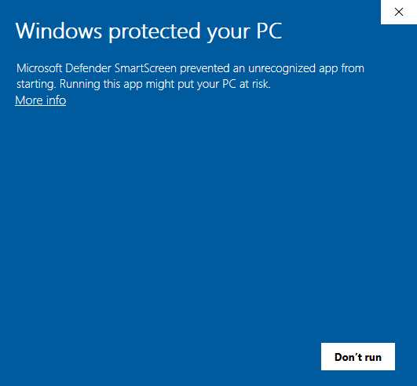

* + 1. Open the File menu and select Manage Packages
    2. Select StarBEAST2 from the list of available packages and click the install button
    3. BEAUti must be restarted to complete the installation of StarBEAST2