Lab 4. Islands of Divergence Name:______________________________

The purpose of today’s lab is to use genomic data to test for a role of selection in divergence. We will continue working with the Eurasian Green-winged Teal (Anas crecca crecca) and the American Green-winged Teal (Anas crecca carolinensis). We will use BayeScan to test for outlier loci (i.e., candidate loci for being under selection) that deviate from background levels of divergence. We will also construct Manhattan Plots that will be examined for islands of divergence. Because BayeScan is computationally intensive, we will restrict our analyses to chromosome 2 only.
Bayescan-overview
- BayeScan can be downloaded from http://cmpg.unibe.ch/software/BayeScan/
- In brief, the purpose of BayeScan is to identify candidate loci that are under natural selection from a sample of genetic data collected at multiple loci. It does so by comparing allele frequencies between two or more populations, and identifying loci that have higher levels of differentiation relative to overall levels of differentiation.
- BayeScan assumes an island model of differentiation, where there are two or more populations connected by gene flow.
- The statistic alpha is measure of how much the divergence at a given locus deviates from background levels of divergence. A positive value of alpha suggests diversifying (divergent) selection (more divergent than expected), whereas a negative value suggests balancing selection or purifying selection (less divergent than expected).
Input File
- Because BayeScan is computationally intensive, we will focus our analyses on Chromosome 2 only.
- Open GWTE.chr2.bayescan using WordPad or Notepad. This file gives the alleles frequencies for each population and each locus.
  - The first line gives the number of loci in the data set. How many loci?______________________
  - The next line gives the number of populations to be examined. How many populations?_______
  - The following lines provide the allele frequencies for population 1 (crecca) and population 2 (carolinensis), separately. Population 1 is listed first; you will need to scroll down to about the middle of the document to find population 2 (or hit Ctrl-F and search for [pop]=2).
  - The first column for the data gives the locus #. The second column gives the number of chromosomes that were typed (i.e., sample size or n, where n = 2N & N is he number of individuals genotyped). The third column gives the number of different alleles. The following columns are the number of samples for each allele.
  - What are the allele frequencies for locus 5 for population 1 and population 2?
→ Population 1 (crecca): ____________________________________________________
→ Population 2 (carolinensis): ________________________________________________

Running BayeScan
- Execute BayeScan (PopGen\BayeScan2.1\binaries\BayeScan2.1_win32bits_GUI.exe).
  - Under “Input”, click on the icon with “…” next to “Genotypes data”. Find your file “GWTE.chr2.bayescan” and click “Open”.
  - Under Output, click on the … to the right of “Output files directory” and navigate to your PopGen\Lab4_Bayescan folder and click OK.
  - Change the “Output files prefix” to “GWTE.chr2”
  - Click on the “Options” tab. This tab gives information about the run parameters. For example, you can change how many iterations (i.e., chains) to run. Typically, we want to run many more to fully explore the data, but given time constraints, we will use the default options. Note that there are parameters for the main chain (under “Sample size”) and for Pilot runs. The pilot runs help explore the data more efficiently.
  - How many chains will we run (Sample size)?_________ How many Pilot runs?________
  - Return to the “Main” tab and click “Start” —The program will now run through a series of iterations to calculate Fst, determine background levels of divergence, and calculate the probability that each locus deviates from background levels (i.e., evidence of selection).
  - If the analysis is running properly, you should see a file called GWTE.chr2_Verif.txt popup on your screen (you can close this file), and see the “Total time” estimate in the lower left of the BayeScan screen fluctuating.
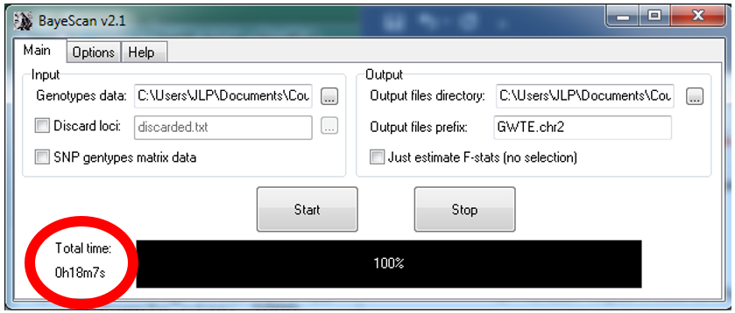
Note: This analysis will take about 30 minutes or more to complete, depending on your computer speed. If you find it takes much longer than that, I can give you the results file.

- Examine the output file with R
  - Type setwd(“type the path of the directory in which you want to work”).
    - For example, my path would be setwd("C:/Users/w048jlp/Desktop/PopGen/PopGen.LabExercies/Lab4_BayeScan")
    - Helpful hint: if your BayeScan folder is open, you can click on the address bar to copy the path and paste it into R. You will need to replace the back slash (\) with a forward slash (/)
    - Type getwd() to confirm that you now have the correct working directory
  - Read your output file “GWTE.chr2_Fst.txt” using the command:
outliers <- read.csv("GWTE.chr2_fst.txt", sep =" ", row.names = NULL, check.names = FALSE)
  - The file header contains unnecessary spaces, causing issues in R. You can fix this by manually removing the extra spaces using a text editor like Notepad or by using R with the following code:
outliers <- outliers[, sapply(apply(outliers, 2, unique), length)!=1]
colnames(outliers) <- c("LocusID", "prob", "log10(PO)", "qval", "alpha", "fst")
  - Verify your data running head(outliers)
    - Your results should be six columns. The first column corresponds to the locus ID
    - The next three columns provide statistics related to selection (i.e., how much better is the model with selection than the model without selection).
      - “prob”: The posterior probability for the model including selection (0 indicates no evidence of selection at the locus, and 1 indicates nearly 100% probability of selection.)
      - “log10(PO)”: how much better a model with selection is than a model without selection, where 1000 is equivalent to infinity.
      - “qval”: q-value, which is equivalent to a p-value; the probability of obtaining the observed or more extreme alpha value if the locus is selectively neutral.
    - The next two columns provide information about the strength of selection
      - “alpha”: The estimated alpha coefficient indicating strength and direction of selection. A positive value suggests diversifying selection, whereas negative values suggest balancing or purifying selection. More extreme values suggest a stronger influence of selection.
      - “fst”: The F_{st} value between the two populations. Note: this is not calculated in the same way that we calculated F_{st} earlier; it is an analog of F_{st} based on model averaging (it is correlated with our traditional F_{st}).
    - Visualize the results by making a scatterplot showing the relationship between the posterior probability and alpha.
      - Plot the data using the command plot(outliers$alpha~outliers$prob).
      - You can get a better plot running the following:
plot(outliers$alpha~outliers$prob, xlab = "prob", ylab = "alpha", type = "n")
abline(h=0, col = "gray")
points(outliers$alpha~outliers$prob, pch=21, col="black", bg="red")
      - Copy the figure using the snipping tool of Windows (Windows, shift, S) and paste in this box. Add a description as a figure legend.

Figure 1.
—Interpret: What can you conclude about the influence of selection in these ducks from this plot?
*Refer to step 8d above to help with your interpretation.

    - Sort your data by qvalue by running head(outliers[order(outliers$qval), ], 25).
    - For determining significance, set a threshold at qvalue = 0.001 and subsample the dataframe.
sub_out <- subset(outliers, qval <= 0.001)
    - After setting our threshold at qvalue = 0.001, which loci (if any) appear to be under diversifying selection (a significantly positive alpha)?
diversifying <- which(sub_out$alpha>=0)
sub_out[diversifying, ]
cat("Loci under diversifying selection:", rownames(sub_out)[diversifying])
    - Which loci (if any) appear to be significantly influenced by purifying or balancing selection (a significantly negative alpha)?
balancing <- which(sub_out$alpha<0)
sub_out[balancing, ]
cat("Loci influenced by purifying or balancing selection :", rownames(sub_out)[balancing])

- Is there evidence of an island of divergence?
    - Visualize the data by making a scatterplot of chromosome number (note that the loci in your list are ranked by chromosome position) and Fst.
plot(outliers$fst~outliers$LocusID)
    - Improve your plot: Label the x-axis “chromosome position”, and the y-axis “Fst”. Additionally, recolor loci that appear to be under selection.
sub_out_div <- subset(sub_out, alpha >= 0)
plot(outliers$fst~outliers$LocusID, main = "Manhattan plot", xlab = "chromosome position", ylab = "Fst", type = "n")
points(outliers$fst~outliers$LocusID, pch=21, col="black", bg="pink")
points(sub_out_div$fst~sub_out_div$LocusID, pch=21, col="black", bg="red")
    - Copy and paste your graph in the box below and give your figure an informative legend

Figure 2.

Questions for group discussion
- Is there evidence of an island of divergence?

- What can you conclude about the influence of selection in these ducks?

