Lab 5. Phylogenomics Name:______________________________

The purpose of today’s lab is to use genomic data to test phylogenomic hypotheses. Mitochondrial DNA suggests that the Green-winged Teal is paraphyletic with respect to the South American Yellow-billed Teal (Anas flavirostris); specifically, A. c. carolinensis is sister to A. flavirostris, not A. c. crecca. However, analysis of morphological characters suggests that A. c. carolinensis and A. c. crecca are sister taxa. We will use nuclear DNA to test these two phylogenetic hypotheses. We will use the program starbeast3, which is a Bayesian implementation of the multispecies coalescent that jointly infers gene and species trees directly from multiple sequence alignments.
starbeast3
- See the document GettingStarted.2025.docx for instructions on downloading and installing starbeast3.
Input File
- Because starbeast3 is computationally intensive, we will focus our analyses on locus from each of 29 chromosomes. The names of the files provide the chromosome number (chr#) and a locus number (an arbitrary number assigned to the locus when assembling the). Note that one locus is linked to the Z sex-chromosome.
- Open Chr1_15A.fas by right clicking on the file, selecting Open with > WordPad
  - This file contains sequences from 4 individuals; because they are diploid, each individual has two alleles (a & b).
  - The samples are as follows:
    - DDG1707 = Anas acuta (used as an outgroup)
    - JLP016 = Anas crecca crecca (the Eurasian Green-winged Teal)
    - KSW3040 = Anas crecca carolinensis (the American Green-winged Teal)
    - KGM267 = Anas flavirostris (South American Yellow-billed Teal)
Creating an Input File using BEAUti
- Go to your BEAST folder and open BEAUti.exe.
- Select File > Template > starbeast3
- Drag your 29 *.fas files (from the InputFiles folder) onto your BEAUti window.
  - A window (Add Partition) will appear. Select Import Alignment from the dropdown menu.
  - Another window will appear for each locus. Make sure nucleotide is selected and click OK (you will do this 29 times).
  - Your BEAUti window should now look similar to the screenshot below.
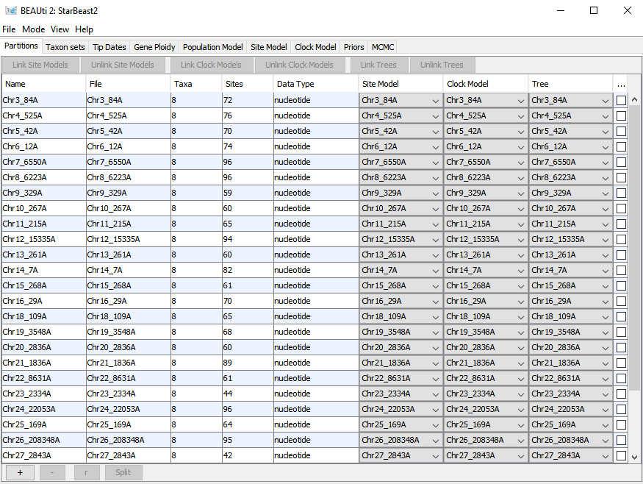
- For simplicity, we are going to use a strict molecular clock for this analysis. In doing so, we allow the rate of molecular change to vary among loci but it is fixed among taxa. If we were going to publish these results, we would want to also explore relaxed clocks.
- Select the Taxon sets tab. Here we will define which sequences belong to which taxon.
  - Under Species/Population, double-click on the “D” for DDG1707a and replace it with A_acuta.
  - Copy and paste A_acuta into the “D” cell for DDG1707b
  - Replace “J” for JLP016a & JLP016b with A_c_crecca
  - Replace “K” for KGM267a & KGM267b with A_flavirostris
  - Replace “K” for KSW3040a & KSW3040b with A_c_carolinensis
- Select the Gen Ploidy tab.
  - Set geneTree.t:ChrZ_1639Z to 1.5 to indicate that this locus is sex-linked (for every 2 copies of an autosomal locus, there are 1.5 copies of Z-linked loci).
  - Leave all others as is (2.0) to indicate that they are autosomal (diploid) loci
- Select the Site Model tab.
  - Set Subst Model to HKY and Frequencies to Empirical. For more complex data sets, we might want to estimate nucleotide frequencies, but here, we can use the actual frequencies.
  - To apply this site model to all loci, select all of the partitions in the left hand column (use the shift key), choose Clone from the locus you already applied the model to (e.g., Chr27_2843A), and click “OK”.
- Select the Priors tab. Here we will tell the MCMC algorithm how to explore parameter space.
  - For Tree.t:Species, select the Birth Death Model.
  - Leave the others the same—in practice, you might want to change the priors on some of the parameters, but we will leave them as is for this exercise.
- Select the MCMC tab. Normally, we would want to run longer chains to better explore parameter space, but given time constraints, we will leave the default run parameters.
- Select File > Save As > Anas.XML

Running BEAST
- Execute BEAST.exe
  - If you get this window, click on More Info and Run anyway
  - 
- When the BEAST window opens, click on Choose File and Select Anas.XML
- Click Run - you will see a lot of information scrolling through the BEAST window. BEAST is reading your input file created in BEAUti.
- When the run actually starts, you should see the following scrolling through. These are the steps of the MCMC and the data that are being collected.
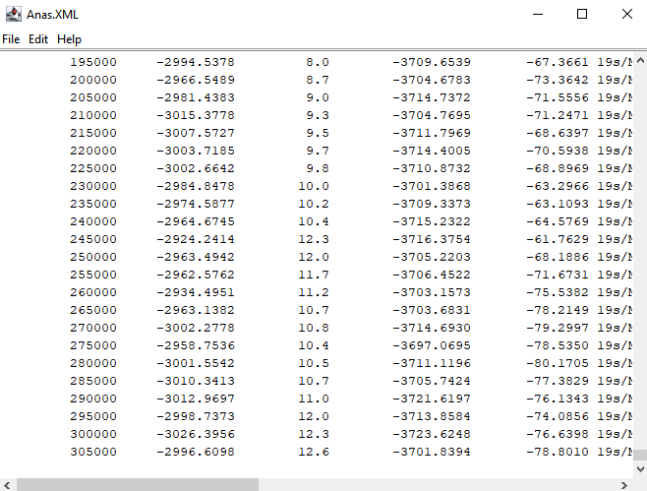
- The amount of time needed for the analysis to complete will depend on your computer speed. Mine completed in about 17 minutes.
- Once the run is complete, return to the folder where you stored your Anas.XML file. Here you will find a variety of new files that were generated.
- We will start by checking how well the MCMC performed
  - Open Tracer from the Lab_5 folder.
  - Find starbeast3.log and drag it into the Tracer window and drop it under Trace File.
  - You should now see a list of parameters that were estimated during the BEAST run.
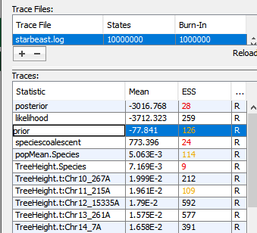
  - The ESS column gives the Effective Sample Size. Each step in the MCMC is highly dependent on the preceding step. The ESS provides an estimate of how many times our steps could be considered independent from earlier steps. Ideally, we want this number to be greater than 200, but 100 is generally sufficient.
    - You should notice that some ESS values are quite low (and highlighted with red font). This indicates that we need to run many more steps before trusting the results.
    - Scroll down and click on popSize.5 to see an extreme case of the issue. Make sure Trace is selected in the panel on the right.
    - This plot shows the parameter estimates that were obtained throughout the run. Although we see plenty of fluctuating values, you should notice peaks and valleys resulting from non-independence. Thus, the over tree height was not explored (or estimated) very well.
    - Now click on one of the parameters with ESS > 500. You should notice greater independence among sequential estimates.
    - So, bottom line, we really need to run this analysis for many more steps (perhaps 100 million or 1 billion). Regardless, we can still learn some things from these results.
  - Look through some of the other tabs to see other information provided by tracer.
- Open DensiTree from your BEAST folder.
  - Select File > Load and choose species.trees from your list of files. Click Open.
  - This DensiTree plot shows all the trees that were visited during the BEAST run.
    - Blue lines show the most common topology recovered; red the second most common; green the third.
  - From the menu on the right, select Show and check Root Canal to see the best-supported tree.
  - What does this tree suggest about phylogenetic relationships (in particular, is A. c. carolinensis more similar to A. c. crecca or A. flavirostris? (We will discuss this plot as a group.)
- To generate a summary tree, open TreeAnnotator from your BEAST folder.
  - Define the burnin as 10% (this will discard the first 10% of trees).
  - For input tree file, choose species.trees (same file used in DensiTrees).
  - Name the output species.trees.summary
  - Click Run.
- To visualize the summary tree, open FigTree from the Lab 5 folder.
  - File > Open > species.trees.summary
  - You should see the same topology as you saw when viewing the best tree in DensiTrees.
    - Hint: to make the tree easier to read, click on the arrow to the left of “Tip Labels” and increase the Font Size.
  - To view support for each of the relationships, check the box for Branch Labels from the menu on the left, then choose posterior from the Display dropdown menu.
    - Increase font size as needed.
    - 1.0 indicates that there is 100% posterior support for the relationship. 0.9 would indicate 90% support, and so on.
—Interpret: How well supported are the relationships in this tree?

—Interpret: Does this tree agree with mitochondrial DNA or morphology?

  - The branch lengths (d) are scaled to time (t) and the mutation rate (μ): d = μt. Therefore, if you have an estimate of the mutation rate, you can obtain an estimate of the divergence time.
    - Under Branch Labels, choose length from the Display dropdown menu.
    - Assuming μ = 1 x 10⁻⁹ substitutions per site per year, when did A. c. carolinensis and A. c. crecca share a common ancestor? _____________________________
Anas crecca and A. flavirostris? ________________________________
Anas crecca and A. acuta? ____________________________________
    - Finally, note that you can also determine the confidence interval for these estimates. Under Branch Labels, choose length_95%_HPD from the Display dropdown menu.
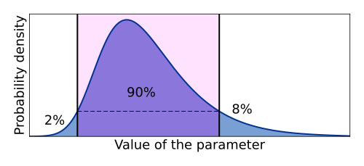
    - 95% HPD is the 95% highest posterior density—the shortest span in the posterior distribution that includes 95% of the parameter estimates. This is often used as the confidence interval when implementing Bayesian methods. See image to the right (Wikipedia).
    - Add the 95% HPD to your estimates of divergence times in step 23.d.ii above.

Questions for group discussion
Why might there be conflicting gene trees based on different markers?

How can we improve our confidence in the results?

